Content Fragments

Follow this tutorial videos

<https://www.youtube.com/watch?v=tES4bexa9KU>

* This feature was introduced from AEM 6.2.
* content fragment allows you to design, create and use page independent content.
* Content fragments are stored as Assets and can be created and maintained from the assets console.
* Any variation that you create from the fragment are also stored within the assets. It is used in page editor by means of the content fragment component (referencing component).
* IT is available to authors. It allows authors to reference the required content fragment.
* Content fragment is a content asset which contains text elements and might include references to other assets.
* That means text, images, videos and even other fragments can be included in the content fragment.
* It is used in page editor by means of the content fragment component. It allows author to reference the required content fragment.
* It can have variations.
* They are defined by a fragment template.

**Note:** Usually the content authoring is not enabled until we create page component and template. After which the page is created using template, then only the authors can drag and drop the components on the page and edit the content.

But content fragments will let the authors to create the content even before the pages are created.

**Content Fragment creation**

To create content fragment, follow the below steps.

1. Go to Tools > assets console > Files > create a folder and inside this create a content fragment and name it tutorial CF.

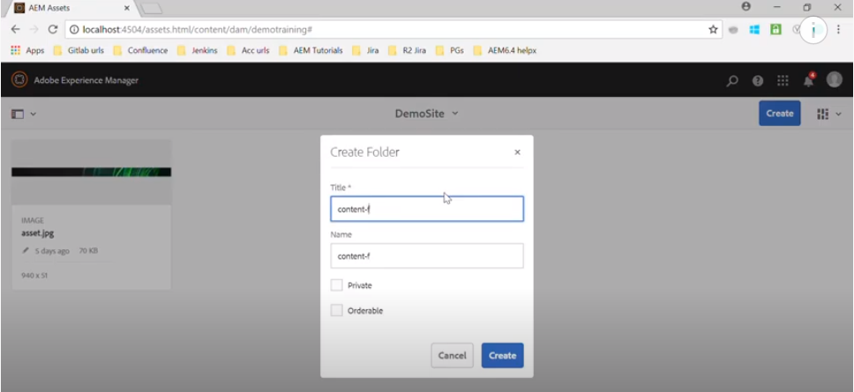

1. Go inside the folder and create -> Content fragment

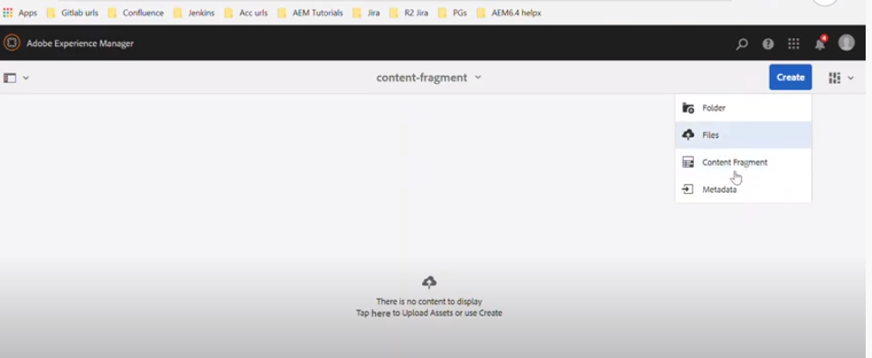

1. By default there will be sample template available to create a content fragment.

Select the template and click on next.

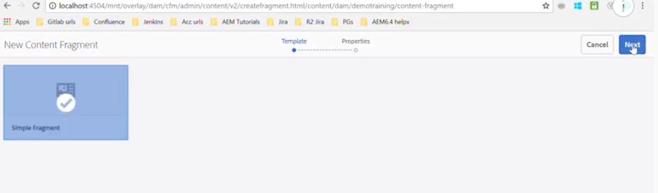

1. Fill out the required fields while creating the content fragment, after which you will see a screen like shown below.

Provide the following details

Title

Description

Tags (if any)

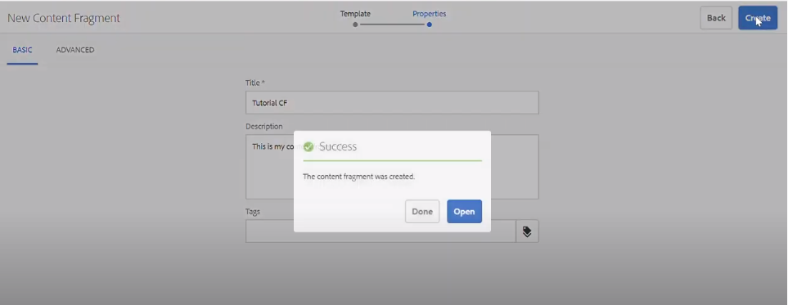

1. Clicking on open will take you to the content fragment that we just created.

Select the content fragment and click on edit or directly click on the content fragment and it will show you the editor mode of content fragment where you can edit the content.

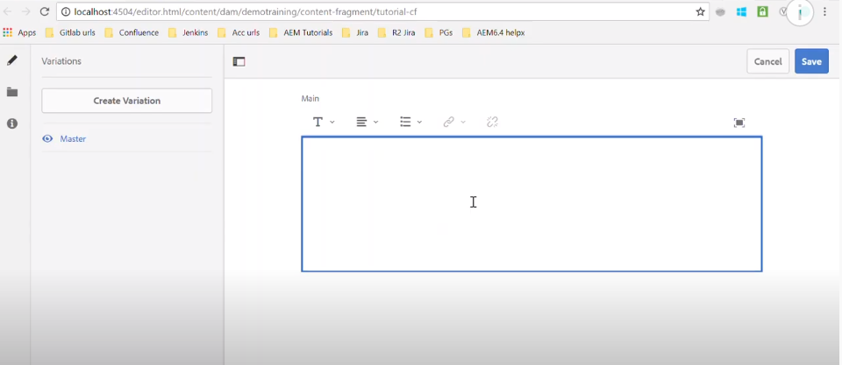

1. We can maximize and minimize the text editor by clicking on the right corner maximize icon.

If you maximize, we will see below listed options.

* RichText
* Plain text
* Markdown.

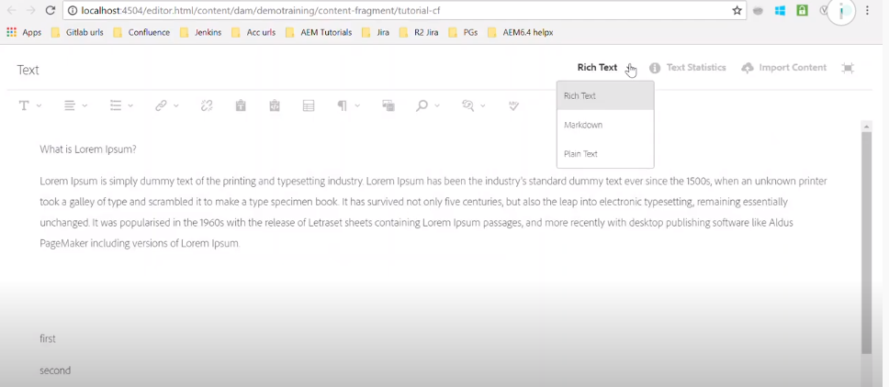

**Creation of variations**

1. Click on the create variation on the left side and provide the variation details.

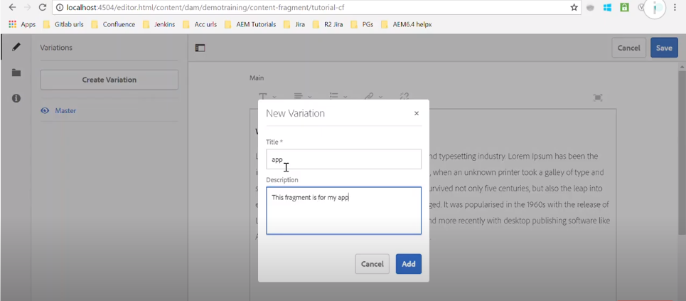

1. After creating the variation, it will be displayed on the left side on the panel.

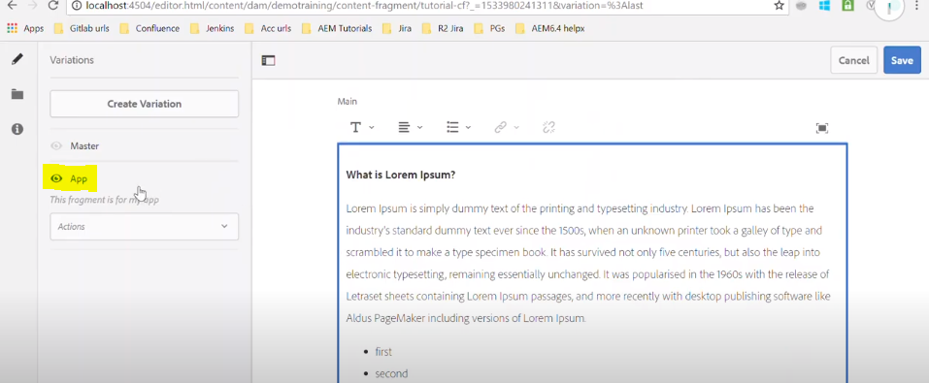

Initially it will copy content as master. Later it can be edited as per the requirement.

1. Once done, go to the page and use the content fragment component where you can drag and drop your newly created content fragment.

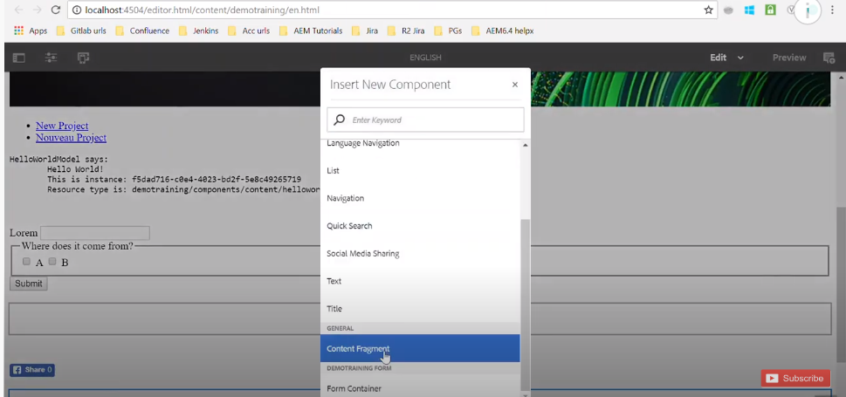

1. Now, from the assets, select the content fragment and drop it over content fragment component You can choose the variation also.

From left panel -> Assets -> Select the content fragment.

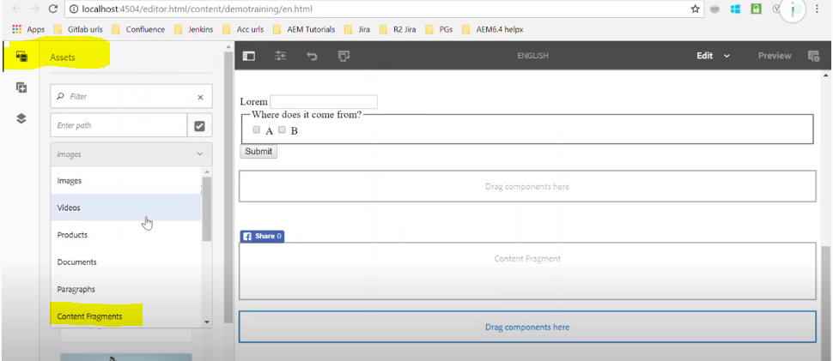

It will display the list of content fragments to be used.

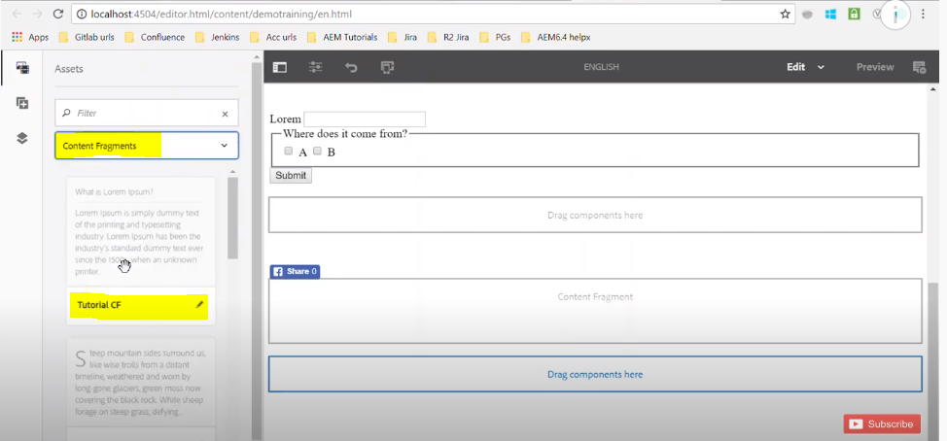

Drag and drop the component and edit it, where we see in settings we will see the following options.

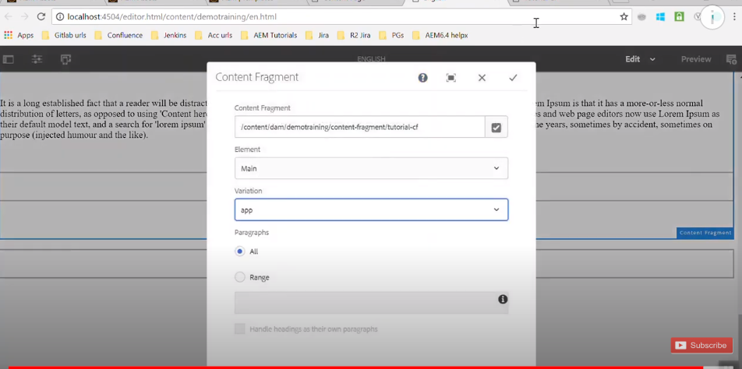

Based on the selection of variation, different content that was created for variations would be displayed on the page.

**Adding image to content fragments**

1. Go to the content fragment location and click on edit. In rich text we will see an option to insert the asset.

Select the path of the asset, it will display the selected image.

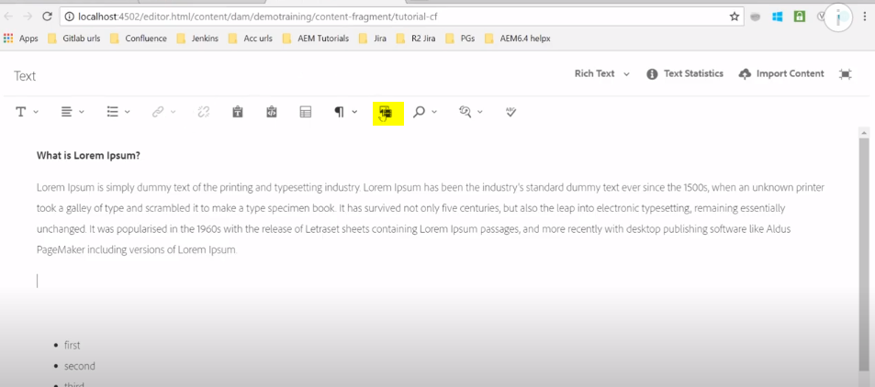

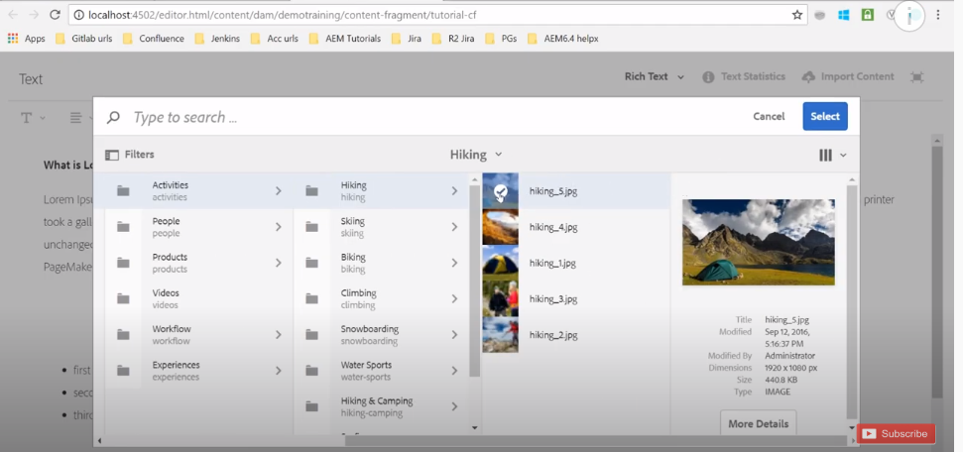

**Content Fragment Model**

Newly introduced in AEM 6.4.

Content Fragment Models define the structure of content for your content fragments.

You can create your content fragment using content fragment models. Content Fragment models work as templates for Structured content Fragments.

To enable content fragment models, you need to:

1. Enable the use of content fragment models in the configuration manager.
2. Apply the configuration to your Assets folder.

**Enable Content Fragment Models in Configuration Manager: -**

To create a new Content Fragment Model you must first enable them using the Configuration Manager

Navigate to Tools > General > Then open the Configuration Browser.

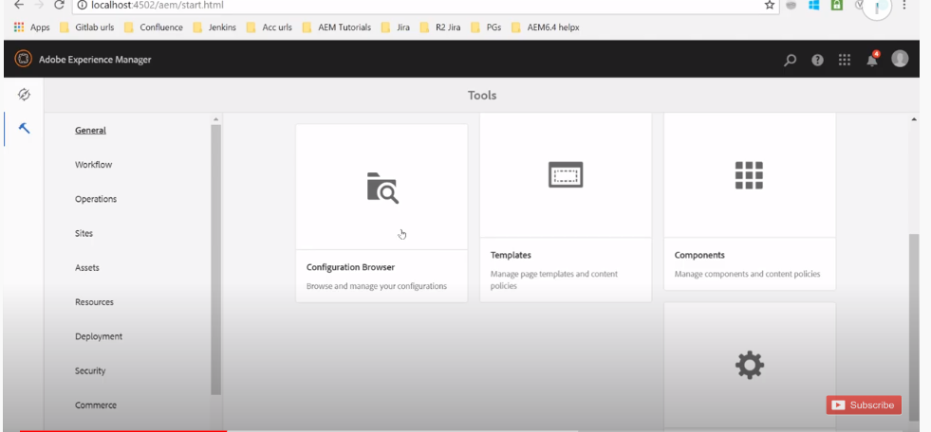

Select the location appropriate to your website.

Use Create to open the dialog, where you specify a Title. Select Content Fragment Models to enable their use.

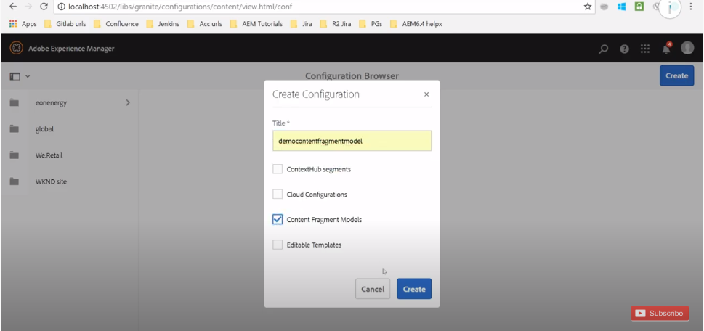

**Apply the Configuration to your Assets Folder**

When the configuration global is enabled for content fragment models, then any models that users create can be used in any Assets folder.

To use other configurations (i.e. excluding global) with a comparable Assets folder, then you have to define the connection. This is done using Configuration in the Cloud Services tab of the Folder Properties of the appropriate folder.

Go to the folder where we will be creating the content fragments. Select the folder > Properties > Go to Cloud settings and provide the model that we have created.

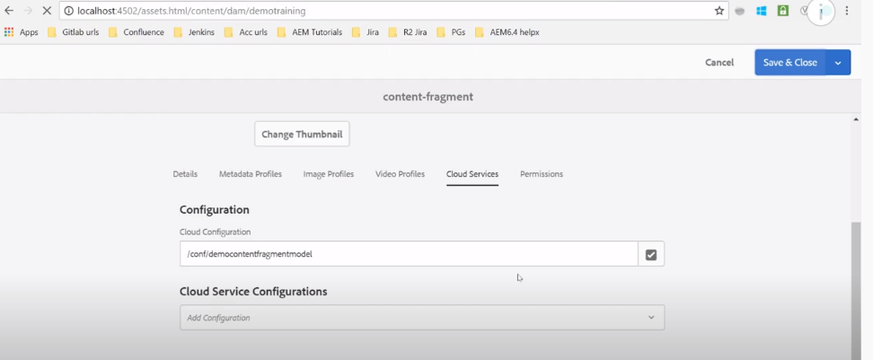

**Creating a Content Fragment Model**

So far we have just enabled the content fragment model but not created the actual model. Now lets go and create a model, where we will create the initial content.

Navigate to Tools, Assets, then open Content Fragment Models.

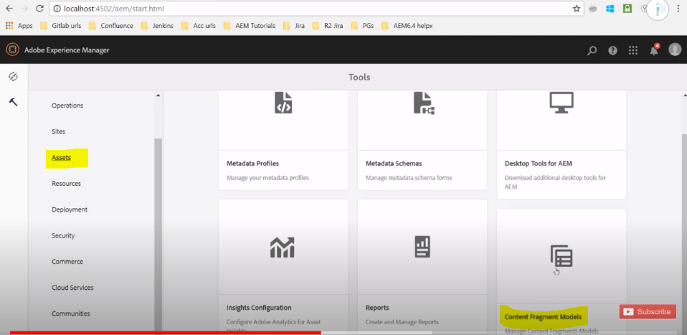

Navigate to the folder appropriate to your configuration.

Use Create to open the wizard. Specify the Model Title. You can also add a Description if required.

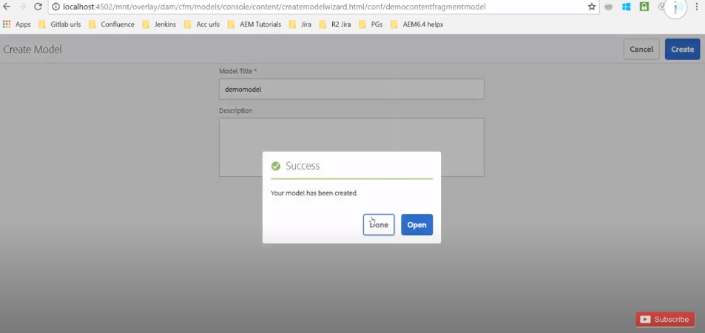

**Defining a Content Fragment Model:-**

The content fragment model effectively defines the structure of the resulting content fragments.

Using the model editor you can add, and configure, the required fields

Navigate to Tools > Assets > Then open Content Fragment Models.

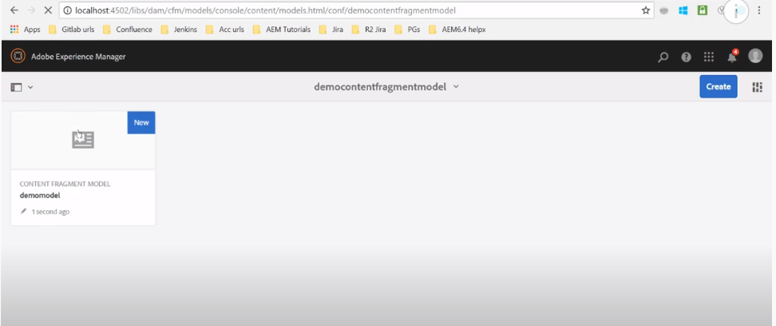

Navigate to the folder holding your content fragment model. Open the required model for Edit.

Use either the quick action, or select the model and then the action from the toolbar.

Once open the model editor shows:

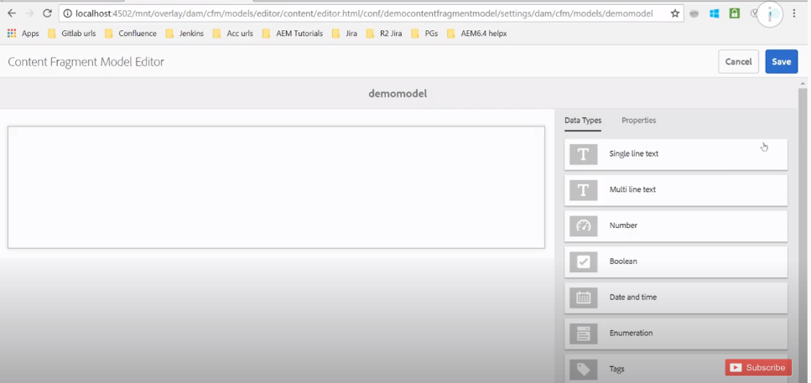

left: fields already defined

right: Data Types available for creating fields (and Properties for use once fields have been created)

Add all the required fields into the model.

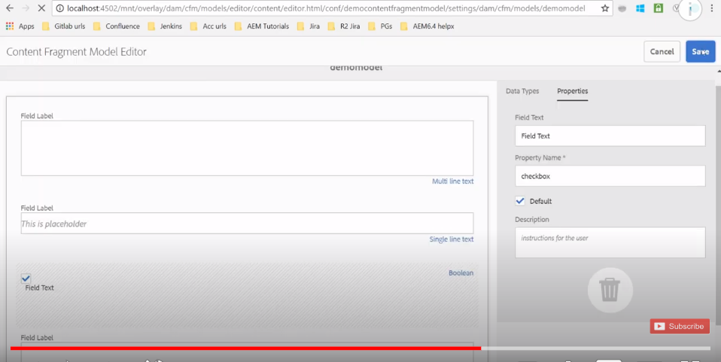

Go back to Tools > Assets > Files > tutorial folder that we have created.

Create a new content fragment with the model that we have just created.

We will 2 models now, one is the simple fragment model and the other is the custom model.

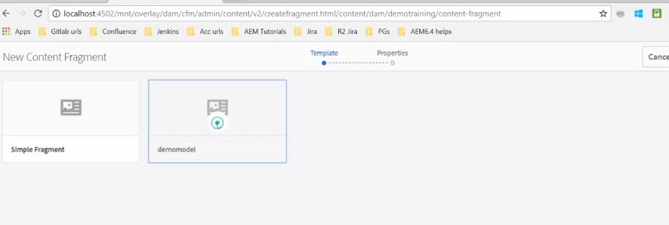

Select the custom model that we have just created and create the content fragment.

By default we will see the structure we have created in fragment model.

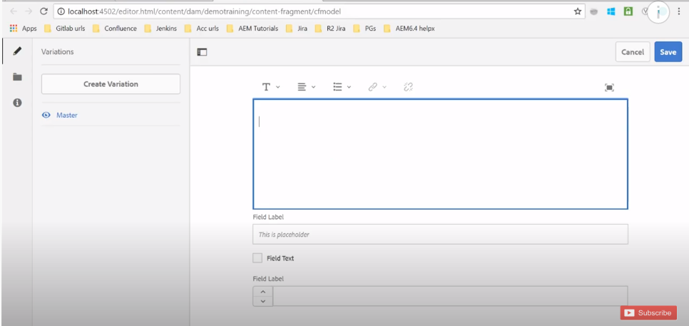

If we go and add the content fragment that we created, it will display all these things on the page.